Decorative sidebar

Version number and date

Title and subtitle

Presenter, company name and address

Carina Appium Automation Framework

Overview

|  |  |
| --- | --- |
| **Practice:** | **Mobile Banking Automation** |
| **Document Owner:** | Tech Team |
| **Version:** | 1.0 |
| **Suggested users:** | Automation/Solution Architect |
| **Author (s)** | Kaveri Keer/Rupesh Sawant |
| **Reviewer (s)** |  |
| **Practice:** |  |

**Contents**

1 INTRODUCTION

1.1 Objective

1.2 Summary

2 HIGH LEVEL DESIGN FEATURES

3 ENVIRONMENT- HARDWARE AND SOFTWARE REQUIREMENT

4 ARCHITECTURE

5 PROCEDURE OF INSTALLING THE FRAMEWORK

6 FOLDER STRUCTURE AND COMPONENT

7 TEST DATA

8 LIBRARY OF UTILITY FUNCTIONS

9 PROCEDURE FOR DEVELOPING AUTOMATION SCRIPTS

10 PROCEDURE FOR CONFIGURING TEST ENVIRONMENT

11 PROCEDURE FOR EXECUTION OF AUTOMATION SCRIPT

12 REPORTING AND LOGS

13 INTEGRATION SCRIPTS IN DEVOPS

14 IMPEDIMENTS

# INTRODUCTION

## Objective

Functional Test Automation, much as it is essential for achieving higher Test coverage and improved Test execution productivity on any project has its own challenges.

In a scenario where the inputs/requirements for any Test Automation project are varied, the need of the hour is to develop a “Test Automation Framework” that can accommodate these varying inputs/requirements and additionally provide the following benefits

* A consistent architecture for the automated solution
* A consistent approach to develop the automated solution specific to each Test Automation project.
* Improved Test script development productivity
* Reusable Utility libraries/functions that an be consistently used across all projects supported by the tool

## Summary

To enable user to understand and use of framework , this document support the way the framework support the development, execution and maintenance of the automation script.

This document will provide the information related to tool, framework components.

# HIGH LEVEL DESIGN FEATURES

Carina framework provides a useful and elegant way of Mobile (Android and iOS) Test Automation.

* Provide a consistent approach for developing automated scripts for Mobile, Web and API
* Productivity increases
* Provide the Code re-usability and ease of development feature.

# ENVIRONMENT- HARDWARE AND SOFTWARE REQUIREMENT

**SOFTWARE REQUIREMENT**

JDK 1.8+

TestNG plugin

Apache Maven 3.5.2+

Eclipse

Maven dependencies (Selenium, Appium)

Universal Driver

SDK Manager

Appium (1.15+ version)

node.js

**HARDWARE REQUIREMENT**

OS : Windows 7, Windows 8, Windows 10

CPU : Min 2 GHz or faster 64-bit (x64) processor

RAM: Min 8 GB

# ARCHITECTURE

carina-demo

|-- pom.xml

|-- src/test/java → Define main test cases

|-- src/test/resources

|-- api

|-- testng_suites

|-- xls→ For Test Data

|-- src/main/java→

|-- Pages → Abstract methods/functions based on application

|-- PageObjects→ Implement methods/functions defined in abstract class

|-- src/main/resources

|-- Config properties->global test configuration.Configure desired capabilities, report path location etc.

# PROCEDURE OF INSTALLING THE FRAMEWORK

**Step 1 :- Install the below software**

**Carina** **Sample** **Framework** : https://github.com/qaprosoft/carina-demo

**Appium Desktop Application set up URL** : <https://github.com/appium/appium/archive/v1.11.2-rc.1.zip>

**node.js Latest Version URL :-** <https://nodejs.org/en/download/>

**Universal driver URL :-** [**https://adb.clockworkmod.com/**](https://adb.clockworkmod.com/)

**Android Studios (SDK Manager):-** <https://developer.android.com/studio/?gclid=EAIaIQobChMI2YyotYbr4QIVhTUrCh0wzA7rEAAYASAAEgJ7GfD_BwE>

After Installing above software Kindly set the “System Environment Variables”

**Step 2 :- System Variable Set up**

1. ANDROID_HOME=Till SDK Path (e.g. E:\Android\Sdk).

2. ANDROID_SWT=E:\Android\Sdk\tools\lib\x86_64

3. JAVA_HOME=C:\Program Files (x86)\Java\jdk1.8.0_131\bin

4. JRE_HOME=C:\Program Files (x86)\Java\jre1.8.0_131\bin

5. Path = E:\Android\Sdk;C:\Program Files (x86)\Java\jdk1.8.0_131\bin;E:\Android\Sdk\tools;E:\Android\Sdk\platform-tools;E:\Android\Sdk\emulator

**Step 3:- Kindly enabled developer option on mobile device**

Kindly Enable the developer option on mobile device.

Go to **Settings** > System > About **phone** on your **phone**. Keep tapping Build number until the message "You are already a **developer**" is displayed. Go to **Settings** > System > **Developer options**

**Inside developer Option kindly enabled the “USB Debugging” option.**

**Step 4: - Device connectivity Check**

Kindly run the below commands from command prompt for getting device connectivity check.

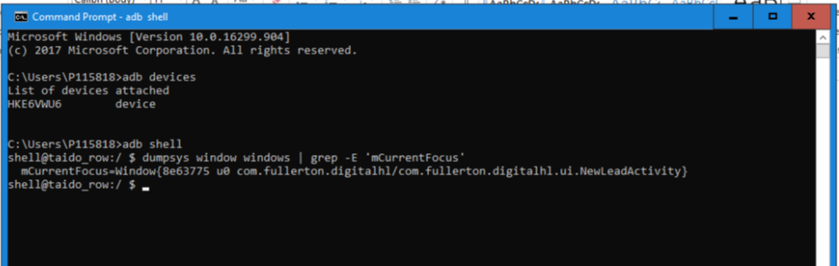

# FOLDER STRUCTURE AND COMPONENT

carina-demo

|-- pom.xml

|-- src/test/java → Define main test cases

|-- src/test/resources

|-- api

|-- testng_suites

|-- xls→ For Test Data

|-- src/main/java→

|-- Pages → Abstract methods/functions based on application

|-- PageObjects→ Implement methods/functions defined in abstract class

|-- src/main/resources

|-- CONFIG PROPERTIES->GLOBAL TEST CONFIGURATION.CONFIGURE DESIRED CAPABILITIES, REPORT PATH LOCATION ETC.

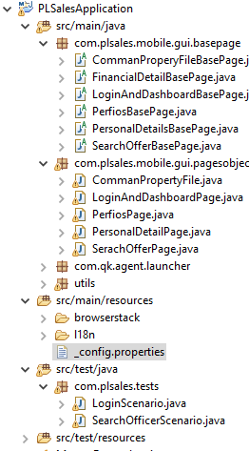

# TEST DATA

For Test Data purpose Developer Excel sheet and can use DataProvider or can read data using Apache POI.

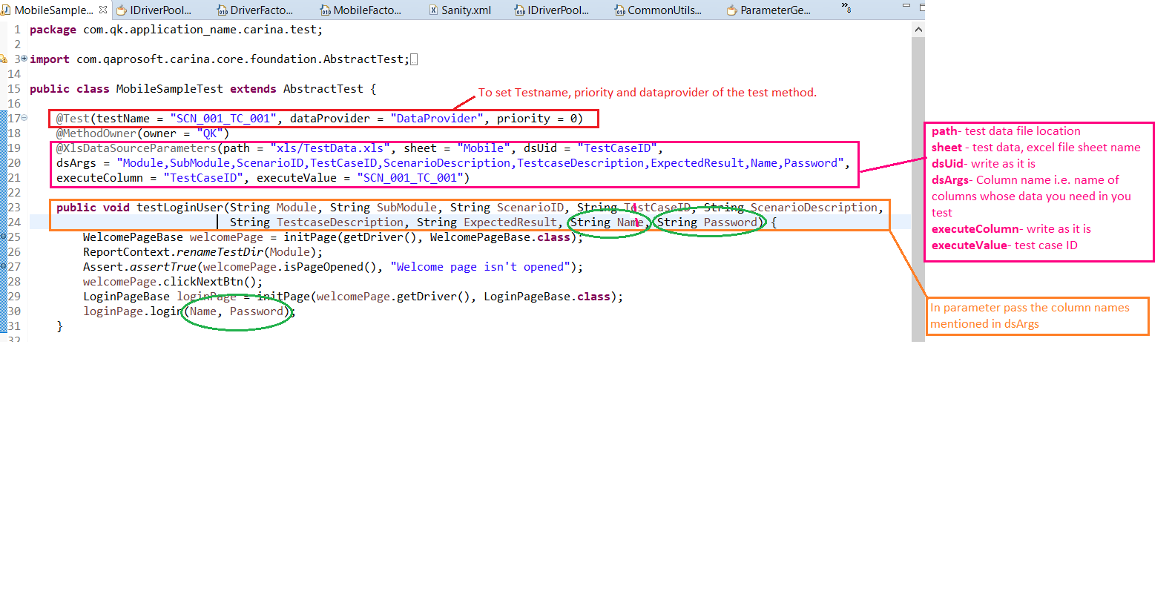

# LIBRARY OF UTILITY FUNCTIONS

# PROCEDURE FOR DEVELOPING AUTOMATION SCRIPTS

1. Developer needs to create the “BasePage” class file for every Page inside src/main/Java/BasePages folder. For e.g In Below example LoginAndDashboardBasePage.java is created inside src/main/java/com.plsales.mobile.gui.basepages and LoginAndDashboardBasePage class will extends AbtractPage class which will bring the driver.

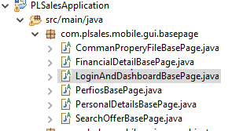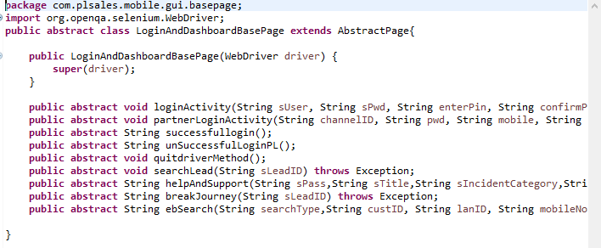

2. For every Base Page we need to create the “Page Objects” class file inside src/main/Java/PageObjects Folder.

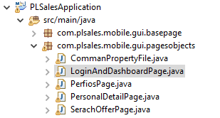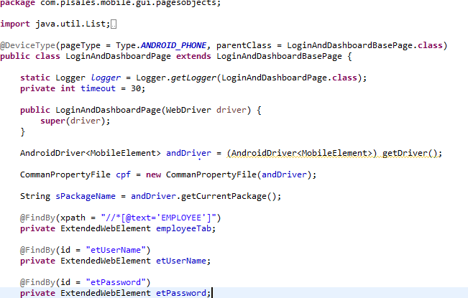

Inside the Page Object User will define the selector and the respective methods which needs to call from the Test

Below are the coding standard need to be follow for the code re-usability and optimal execution.

1. Kindly define the Class Name staring from the capital Letter(i.e public class LoginPage )

2. Kindly define the method name and variables as a Camel Casing (I.e String sName and public void boolean loginMethod())

3. Kindly use the Try-Catch block for the Exception handling inside the “Page Objects” as well as ‘tests”

4. Try to create the common methods for creating the keywords or any action to perform.

PFB screenshot for the same.

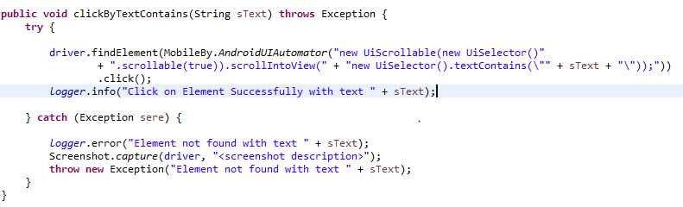

3. Write the Test cases inside the src/test/java folder path

for e.g in below screenshot developer has created the tests inside src/test/java/com.plsales.tests/LofinScenario.java

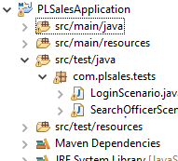



# PROCEDURE FOR CONFIGURING TEST ENVIRONMENT

For Appium , need to set the Appium parameters in _config.properties file

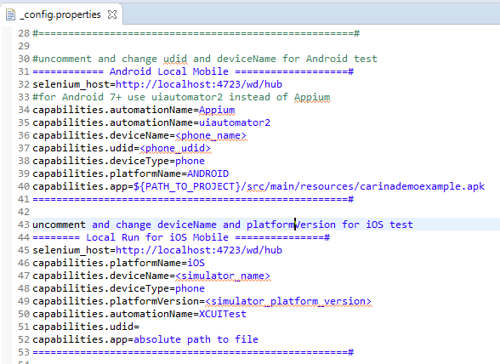

# PROCEDURE FOR EXECUTION OF AUTOMATION SCRIPT

To run test suite from Eclipse IDE, just select the required TestNG xml file: Right click > Run As > TestNG suite

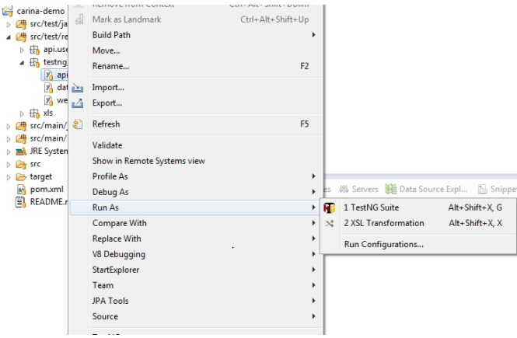

# REPORTING AND LOGS

# INTEGRATION SCRIPTS IN DEVOPS

# IMPEDIMENTS

https://qaprosoft.github.io/carina/automation/mobile/

https://qaprosoft.github.io/carina/